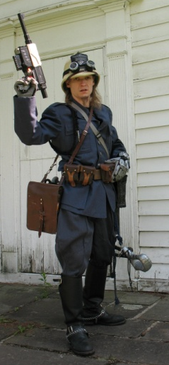
Name: Captain Maximillian Drake
Age: 33
Gender: Male
Occupation: RAF Dreadnaught Class Airship Captain, Gentleman Businessman/Importer of Luxury Goods (Gentleman Smuggler)
Preferred Weapons: 1796 Light Cavalry Saber with Spec. Titanium Blade in conjunction with Hydraulic augmented prosthetic Arms; The Prosthetic arms themselves; Broomhandle C96 Mauser Pistol; Ship’s Gunnery
Languages: English (first language), Latin, Italian, French, German, Spanish, Farsi, Mandarin Chinese, Japanese, some Russian
Country/Town of Origin: London, England
Vehicles Owned:
The HMS Wyvern (owned by the RAF Airship Division)- a 650 ft. X 90 ft. Dreadnaught Class airship with 500 crew of Royal Air Marines and other personnel
The HMS Stormcrow (personal ship but resides in the belly of the Wyvern)-a 150 ft. X 40 ft. Heavy Fighter Zeplin
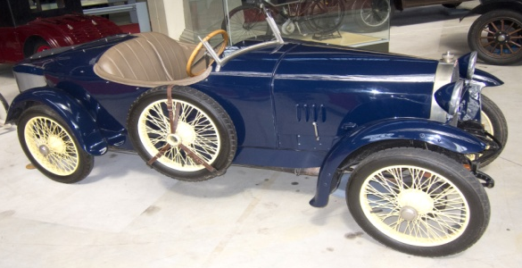
Bugatti Type 23 Brescia (2-seater roadster/touring model)
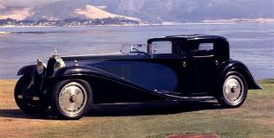
Bugatti Type 41 Royale (Limo with driver)
Profession/Job(s) and skills:
Profession/job: Highly decorated RAF commissioned officer-Captain of the HMS Wyvern; Gentleman smuggler of luxury goods and other things (use your imagination here); Owner and founder of Drake Imports International a luxury import company with world wide scope, which has made Captain Drake independently wealthy.
Skills: Aeronautical engineering (spec. Airship engineering), Engineering (Steam and Mechanical), Navigation, Airship pilot, Airplane pilot, Drive (motor vehicle), Heavy Equipment Operation(cranes, earth movers, steam powered machines including locomotives, etc.), Horseback riding, training in multiple forms of martial arts, Firearms (both regular and energy types), Fencing(sabre as spec.), Marksmanship, Business and Finance, Appraisal (spec. Luxury goods),History, Philosophy, many foreign languages.
Character Appearance:
5’5” about 135 lbs., wirey. Hazel/green eyes, slightly below the shoulder length blond hair(very nordic looking). Has 2 prosthetic metal mechanical/hydraulic augmented arms from the shoulder down, which depending on the situation can be seen from the shoulder down(unbuttoned sleeve) or just the metal hands and wrists(buttoned sleeves). The right arm has a built in power drill on the bottom of the forearm. The left arm has a built in welding torch on the forearm, and a built in com unit/radio at the wrist and a built in Stun gun on the back of the mechanical hand.
Wears the uniform of an RAF Air Ship Captain (Blue wool 4 pocket tunic with heavily modified arms that unbutton all the way to the shoulders to accommodate mech./hydaulic prosthetic arms and tons of medals on the chest area, Grey Jodhurs with a black strip running down the side, tucked into knee high black leather riding boots with silver spurs, and a tan tall empire style pith helmet with a large RAF Airship Corps. Badge on the front and goggles with various attatchments directly under it). Wears a pistol belt around the waist with 4 extra C96(Broomhandle Mauser) clip pouches and always a spec. made (titanium)1796 Light Cavalry Sabre in a metal sheath hanging from the left side. Often times wears a brown leather scatchel/map case on the right side over one shoulder and always a Broomhandle Mauser in it’s gunstock/holster on the left side with the sword over the other shoulder. Often wears a jet pack.
Background Information:
* Is a distant descendant of Sir Francis Drake
*Grew up in a moderately wealthy family
*Graduated from Oxford with a degree in engineering (partly while in The Royal Air Marine Academy)
*Joined the Royal Air Marine academy at age 20 and became a commissioned officer serving as a Lieutenant aboard his first airship by age 25.
* at age 27 survived a horrible airship crash aboard his first airship but his arms were crushed so badly they had to be amputated, almost ending his military career. However, an excellent surgeon (now the ship’s doctor aboard the Wyvern) found all the nerve endings and successfully attached them to electrical plugs. These in turn plug into the corresponding Mechanical prosthetic arms that a watchmaker/mad scientist inventor built for Captain Drake, saving and one could say improving his career.
*As a highly decorated RAF Airship Captain, Drake soon caught the attention of the British Crown and government he serves. In his duties as such he has at times acted as a privateer for the British Crown and mostly as escort for supply convoys to the far flung British Empire. Her Majesty, the Royalty, and the government owe him many debts of gratitude for helping them with various top secret “policies” of state that not only do they look the other way when it comes to his smuggling activities, they are some of his best clients and investors in his “legal” import business.
*While independently wealthy, Drake is consumed by his work, and spends very little time at home in his mansion in England. His home away from home tends to be the HMS Wyvern. He is not married, has no kids, and tends be a benefactor to many others (especially promising but poor or hard on their luck folks) as a result. He tends to be humanist in nature while at the same time doing a lot of going along to get along (example hates the British govt.’s policies concerning their illegal opium trade in China. Drake doesn’t do anything to stop it because he knows it’s too big for him to stop himself, but refuses to participate in it), which has served him quite well considering.

